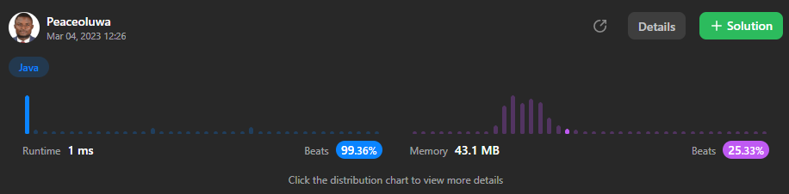

Question 1 - Two Sum

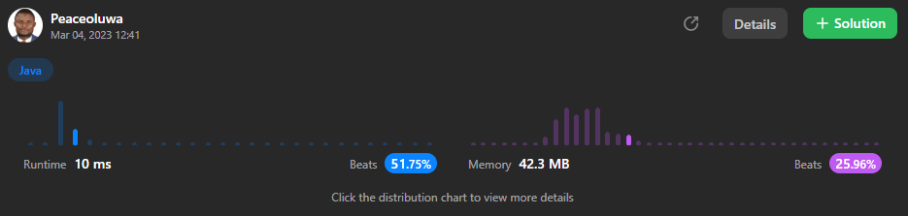

Question 9 – Palindrome Number

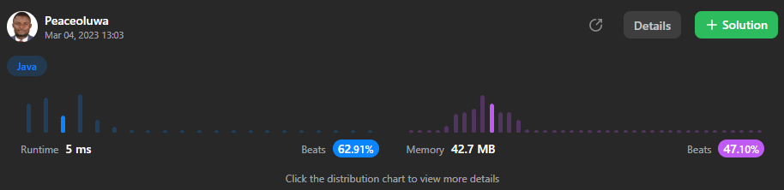

Question 13 – Roman to Integer

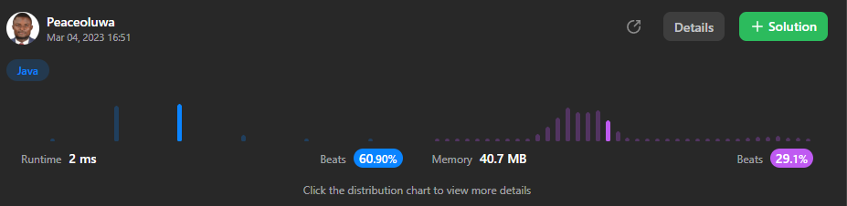

Question 20 – Valid Parentheses

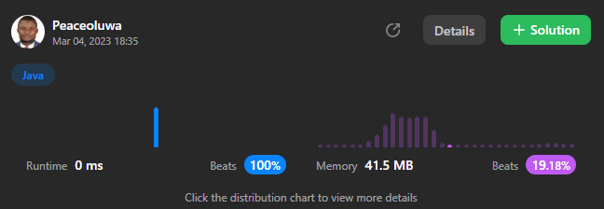

Question 27 – Remove Element

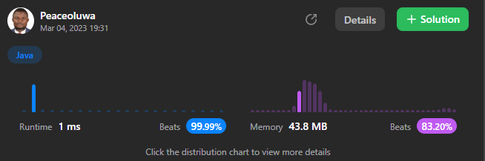

Question 26 – Remove Duplicates from Sorted Array

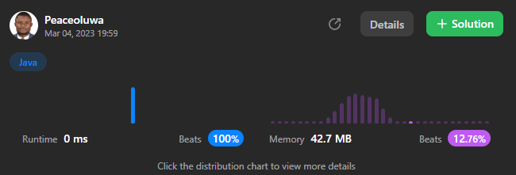

Question 35 – Search Insert Position

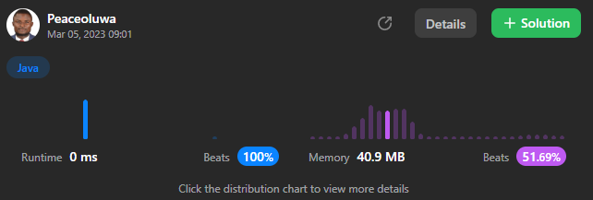

Question 66 – Plus One

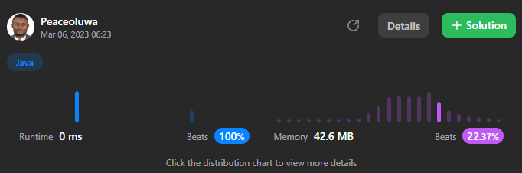

Question 88 – Merge Sorted Array

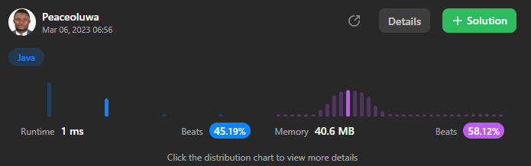

Question 58 – Length of Last Word

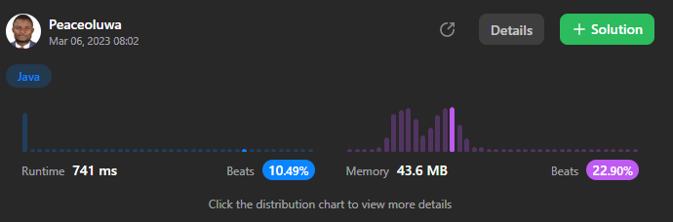

Question 125 – Valid Palindrome

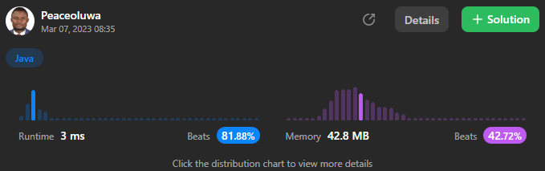

Question 242 – Valid Anagram

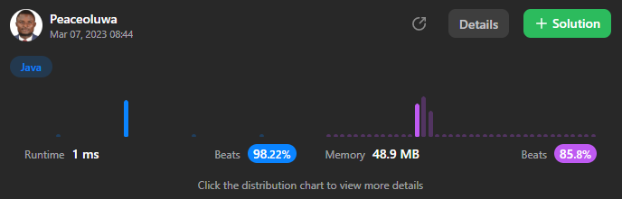

Question 344 – Reverse a string

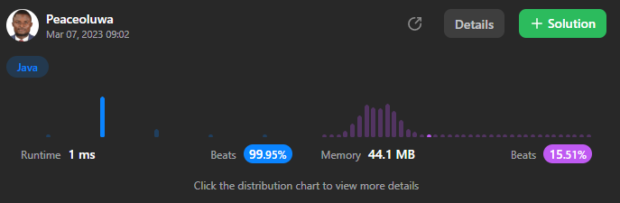

Question 412 – Fizz Buzz

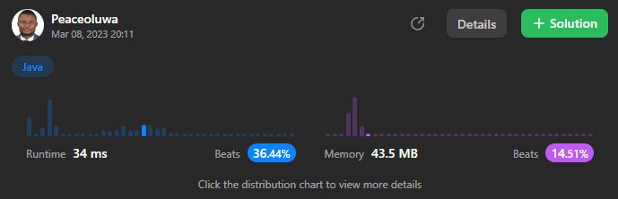

Question 387 – First Unique Character in a String

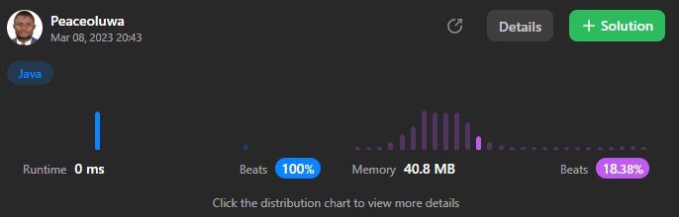

Question 2351 – First Letter to Appear Twice

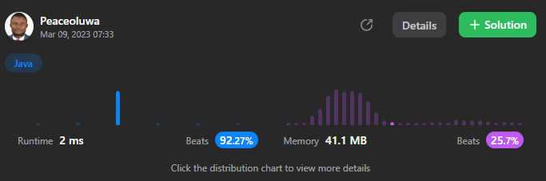

Question 1207 – Unique Number of Occurrences

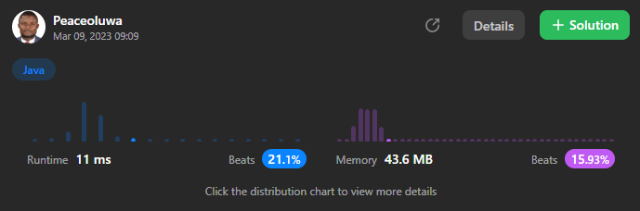

Question 680 – Valid Palindrome II